JUST ONE OPPORTUNITY JANUARY UPDATE

Address: 708 Kings Grant court, Virginia beach, Virginia 23452

Just One Opportunity’s Mission: To break the cycle of poverty in remote villages of Nicaragua through the practical expression of Christ’s love.

PRAYER REQUESTS

- Pray for our team: Ana Julia Vilchez - In- Country Director, Jazmina Sequeira – Lead volunteer Pastors: Rafael Padilla, Rosario Jarquin, Erik Gomes ,Jemerito Matamoro and Santiago Zelaya and our teachers: Lilliam Vilchez, Emiliano Vilchez, Osaida Oboando, Carla Altamirano and Aracely Padilla.
- We need an administrative volunteer who can help 10 hours a week (US side)

How Can I get involved?

- Event planner: set up for events, plan events to speak at either churches or other venues
- Supplies collector: Coordinate a supplies collection location (school supplies and medical, clothes and shoes)
- Mission Planner: This person will coordinate all the logistic involved in getting a team to Nicaragua once a year. This person will work closely with Roger to plan the mission trip.
- Education advocator: This person will recruit teachers and encourage them to come to Nicaragua and do teachers training in Nicaragua
- Promote Just One Opportunity: Like us in Facebook, subscribe to us on YouTube and share with others about Just One Opportunity
- Go to Nicaragua with us and help us train teachers, pastors or work on projects.

Evangelism Update
- On January 14, 2017 we were able to meet with the pastors from the twelve villages and created a plan to reach out to other villages and disciple leaders to spread the Gospel
- During a brainstorming session, many training topics came up. Three of them were:
  - How to disciple and raise leaders within the church?
  - What it means to serve in God’s Kingdom?
  - How can we more effectively share the Gospel in remote villages without churches?
- We were able to plan training events for the entire year for pastors and elders of the church and marriage couple

Education

- We met with the college and high school students and their parents and we shared about trusting God with everything we have and the importance of being thankful towards God for the opportunity to receive an education
- We met the teachers that we sponsor to discuss our supportive role as they strive to provide a quality education to the elementary children. The teachers were encouraged as we shared with them that their work is making positive impact on their communities.
- On January 13, we were at the school where Roger Orozco attended. We provided 120 uniforms to elementary school students who are living in extreme poverty. Their parents are often times unable to afford a school uniform which prevents a child from attending school. The students received a uniform, pair of shoes, backpack, five notebooks and pencils. About 300 people attended this event and the local representatives were extremely thankful for the support provided by Just One Opportunity

Practical needs

During our most recent mission trip, we did the following:
- We brought about 400 toothpastes and brushes
- We brought tools for Henry to help us repair and improve the school in Albellanas and in the community
- We met with a group of engineers who are working with Just One Opportunity to build a bridge across a main section of a river. This is the same river that Roger crossed as a child.

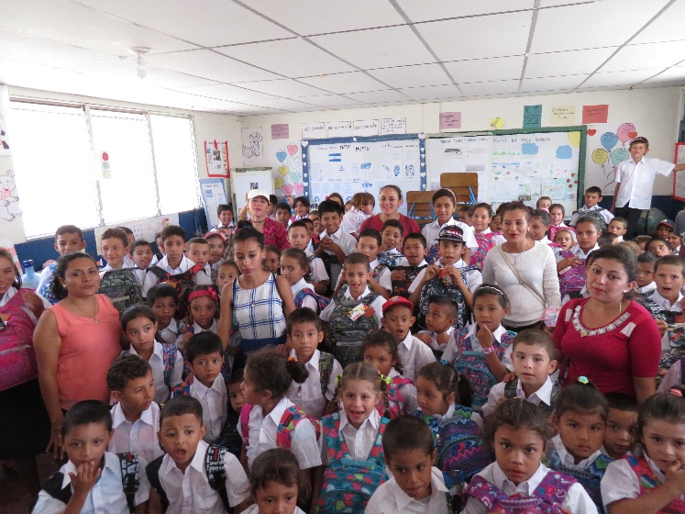
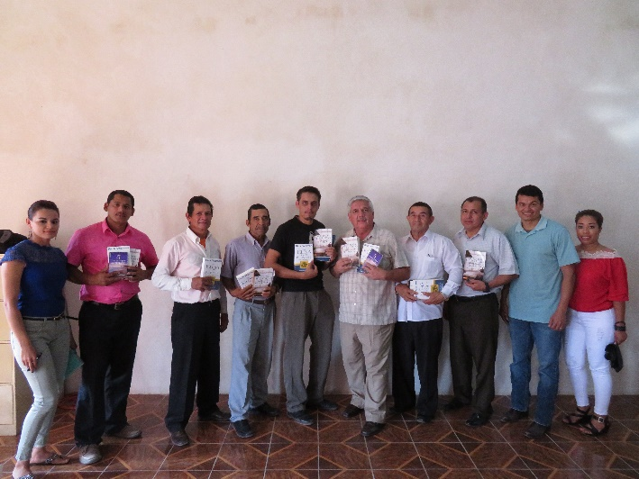
120 Elementary school students receiving uniforms
Pastors with training materials for 2017
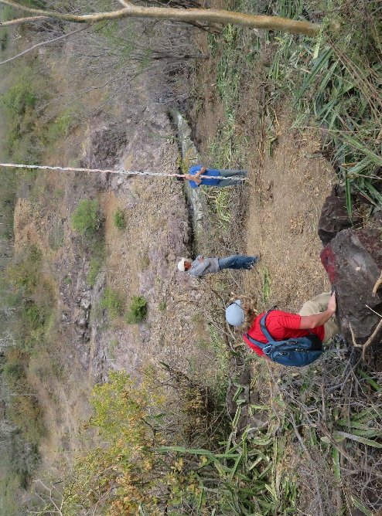
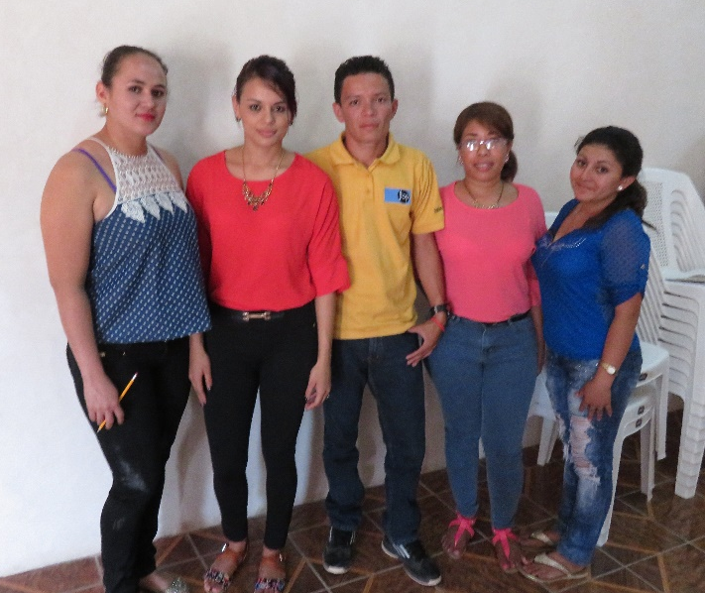
Measuring the distance of the Bridge
Teachers Meetings from the villages

